**Soil Lab Data Mart Modernized: Soil Data at Your Fingertips**

**[city], [state] – [month] [day], [year] –** The USDA Natural Resources Conservation Service (NRCS) [National Soil Survey Center](http://www.nrcs.usda.gov/wps/portal/nrcs/detail/national/contact/centers/nssc/?cid=nrcs142p2_053895) announces the release of updated geochemical data to an interactive map called [National Cooperative Soil Survey (NCSS) Soil Characterization](https://nrcs.maps.arcgis.com/apps/webappviewer/index.html?id=956154f98fc94edeaa2dbad99bb224af&fbclid=IwAR02FH-eOgfWwGfUtQ0uzTltXwp2cbfGphMHUJlCjQcxKQNPl8lNPY8JZRg) offsite link image    .

The map links to a national database of soil characterization data and allows users to locate pedons that have been analyzed. A pedon is the smallest unit of soil containing all the soil horizons of a particular soil type. Clicking on a pedon location in the map enables users to access lab data about that pedon. The map is also available from the [NCSS Soil Characterization Basic Query](https://ncsslabdatamart.sc.egov.usda.gov/) website by clicking an icon at the bottom left of the page.

* Modernized KSSL lab data website to make the NCSS lab data mart web page more intuitive for the user, making it easier to navigate and find information.
* Retained historical method for querying lab data and accessing query results.
* Implemented process for updating lab data on a regular basis.
* Updated deliverable databases to include open-source databases and companion morphological data. Nearly all data in the Kellogg Soil Survey Laboratory and the associated pedon data are available for download. Customers can download SQLite, Access, GeoPackage, and ESRI File Geodatabases.
* Updated deliverable database so they utilize new simplified database model schema.
* New lab data model tables and columns available.
* Interactive metadata documentation available for new lab tables.
* Replaced ESRI Web map with open-source leaflet map and automated the data.
* Enhanced map interface to allow users to create custom AOIs and download data in the database format of their choice.
* Lab tables also assessable through Soil Data Access API. Developers and data scientist can access NCSS Characterization Data through the Soil Data Access (SDA) application and SDA webservices. Use the SDA query page to submit custom SQL queries through the SDA application and receive instant or e-mailed tabular results in xlm, html, or text format. A suite of SDA webservices are available to meet a variety of customer needs. The pedon data associated with the NCSS Characterization data are not available through SDA.
* MIR data displayed on the map and available for download.

“The updated website and map gives users nationwide a means to view data that can be used by educators, scientists, farmers, landowners, schools, soil judging teams, the general public and more,” said [Name], State Conservationist in [state].

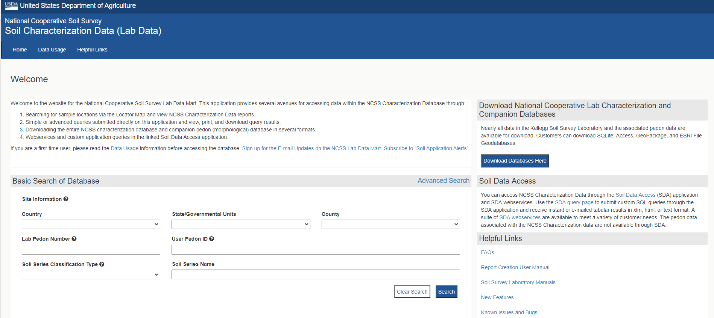

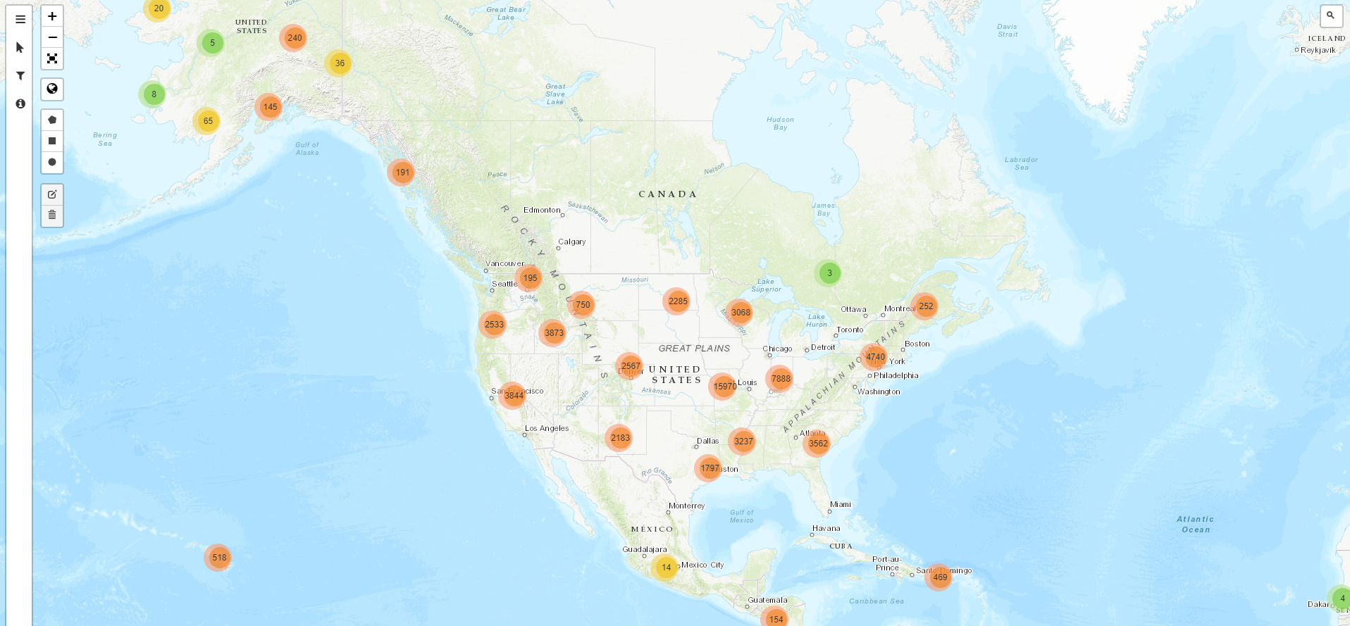 “The map lets you search for lab data by using filters or by exploring places you care about across the globe,” explained [First Name] [Last Name], State Soil Scientist in [State]. Map users can query by location of interest and have soil data available at their fingertips.

The updated tool can assist scientists in developing conservation models for validating outcomes of conservation practices. Users can pinpoint spots using location panels, full-screen maps and latitude and longitude. “Our new interactive map provides online access to our rapidly growing collection of lab data,” explained Skye Wills, National Leader for Soil Science Research.

Soil scientists, hydrogeologists, municipal water-utility operators and water-quality regulators use soils lab data to understand the subsurface. The data viewer includes over 50,000 individual soil samples from across the world (see map for U.S. sites). Soil sample data can also be viewed in reports. The website offers:

* options for selecting different base maps and adding soil-color maps by depth-slice,
* the ability to search by location or use a current location,
* the ability to search by soil series or geographic location,
* options to download characterization data for a selection of points to be used in other applications,
* two ways to search for lab pedons, filters and the search bar and
* streaming from Soil Data Access web services, where popups for each pedon include several lab reports.